Sunday, September 22, 2024
1:01 PM

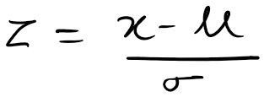

Z is the Z score that we are calculating
X is the specific data point we want to evaluate
µ is the mean of the dataset
σ is the standard deviation
If Z score is greater than threshold : This suggests that the data point is a unusual or outliers.
In Other words, they are significantly different from the mean of the dataset.

If Z score is less than threshold : This suggests that the data points are usual and can be worked with.

